Chindits struggle through Burma jungle

7th March 1943: Operation Loincloth: despite many privations and heavy casualties, an unconventional British force surprises the Japanese
MAR 7

SAVE |  | ▷ LISTEN

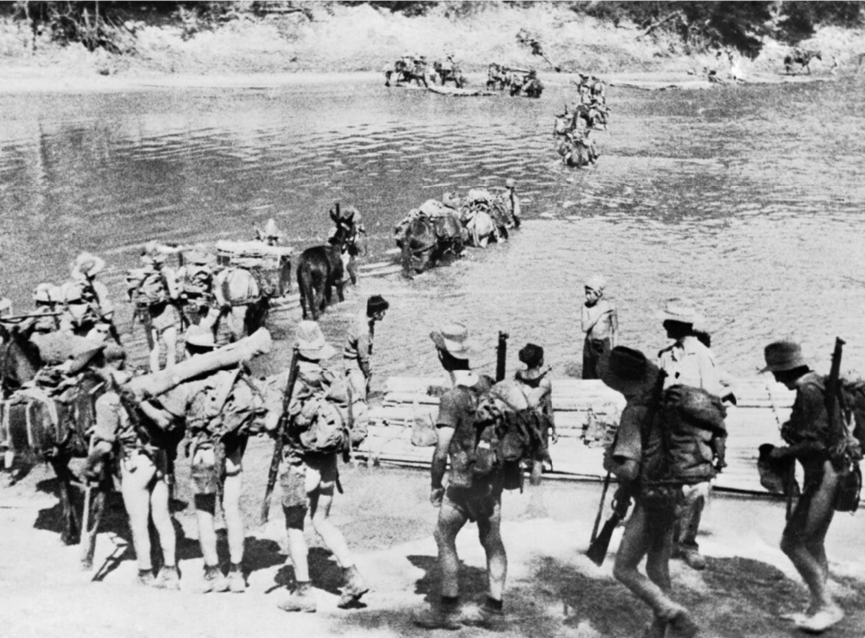
A Chindit column crosses a river in Burma.
In Burma, now occupied by the Japanese, the British were experimenting with unconventional methods of warfare. Colonel Orde Wingate had won support for the development of a deep penetration guerrilla force that would march far into the jungle, way behind the front line. There they would disrupt the enemy's lines of communication by blowing up railway lines, as well as attacking Japanese troops. The new force - officially “Long Range Penetration Groups’ - soon became christened 'Chindits', a corruption of the Burmese name for the lions that feature in their myths.
Churchill and others in the British High Command at first believed that they had found another ‘Lawrence of Arabia’ in Orde Wingate. The notion of a special force operating behind the lines and stirring up the native population against the Japanese held considerable appeal. The reality of marching 3,000 men into the deep jungle, climbing over mountains and improvising river crossings would be less romantic. The lessons of training exercises in India, during which 70% of the men became casualties through illness, did not appear to have been learnt.
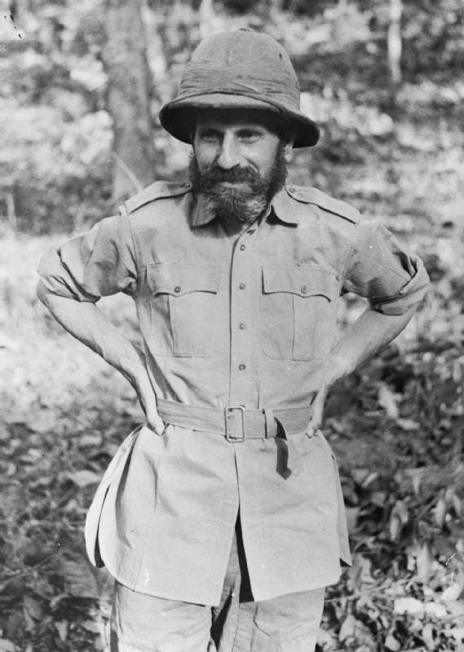
Orde Wingate ( 1903-1944) after returning from his 1943 operation. He was seen by many as eccentric - he was known to wander around naked, munching on onions and garlic, whilst giving orders. Others, including Churchill’s physician Lord Moran, regarded him as borderline insane.
To imagine that men could keep fit on a ration of this nature for three months of marching through very rough country, fighting, physically and mentally extended, is beyond belief, and would seem to show a definite lack of imagination in planning the ration menu.
The conditions the troops were expected to live in were arduous enough. However, the problem of resupplying such troops by air was also experimental, and was to lead to further privations. The first column set off into the jungle in late February 1943 and received its first parachute drop of supplies in early March. Harold James¹ was a nineteen-year-old officer on his first military operation:
The dropping area was strewn with ration tins, parachutes and mule fodder, and the men soon got to work collecting the stores. Burmese from the nearest village were called in to help, and in return were given the parachutes which they greatly prized, cloth being a scarcity. We soon learned that valuable information could often be obtained for a piece of parachute. The Gurkhas made handerchiefs and ration bags for themselves, and lanyards from the cords.
Four tins were dropped with each parachute, padded with a shock absorber fastened by thick webbing - although this did not always work if the parachute should break loose. The four tins could conveniently be loaded each side of a mule, allowing extra rations to be carried as reserve, and, as on this occasion, the supplies could be easily transported from the dropping zone to our camp for distribution to the men.
The hard scale daily ration laid down was:
Shakapura biscuits 12oz
Cheese 2oz
Milk powder 1oz
Raisins and almonds 9oz
Tea 3/4 oz
Sugar 4oz
Acid drops or chocolate 1oz
Salt1/2 oz
Cigarettes 2 packets of 10
Matches 1 box
To imagine that men could keep fit on a ration of this nature for three months of marching through very rough country, fighting, physically and mentally extended, is beyond belief, and would seem to show a definite lack of imagination in planning the ration menu.
But the expedition was heading into unexplored areas of logistics, and presented problems which had to be solved by guesswork before hard experience could produce the correct results.
There was no meat, although tins of corned beef were dropped later, and on occasion corned mutton for the Gurkhas. But it was bulky, and went bad quite quickly, so had to be eaten more or less in one sitting.
The parachute ration was supposed to be supplemented from local produce, which often proved impracticable. With over 300 mouths to feed, very few villages could provide more than a few mouthfuls of rice per person, and the odd chicken or egg. Some columns were lucky in coming across an extra friendly village which would be more helpful - but seldom more than once during the expedition.
It was also assumed that supplies would be dropped regularly, which turned out, after the first two drops, to be a false hope, not because of any shortage of aircraft, just that the enemy’s presence often made it impossible to pick and choose time and place.
The idea behind the rations selected was that they contained nothing that required cooking, except water for tea, since it was expected that troops would not be able to count on more than twenty minutes for meals. In practice
we rarely had to rush our meals.
It was also assumed that supplies would be dropped regularly, which turned out, after the first two drops, to be a false hope, not because of any shortage of aircraft, just that the enemy’s presence often made it impossible to pick and choose time and place.
As a result, for most of the expedition, one day’s rations had to last at the very least for three, and too often much longer.
A great deal of will power was needed to limit the daily intake.
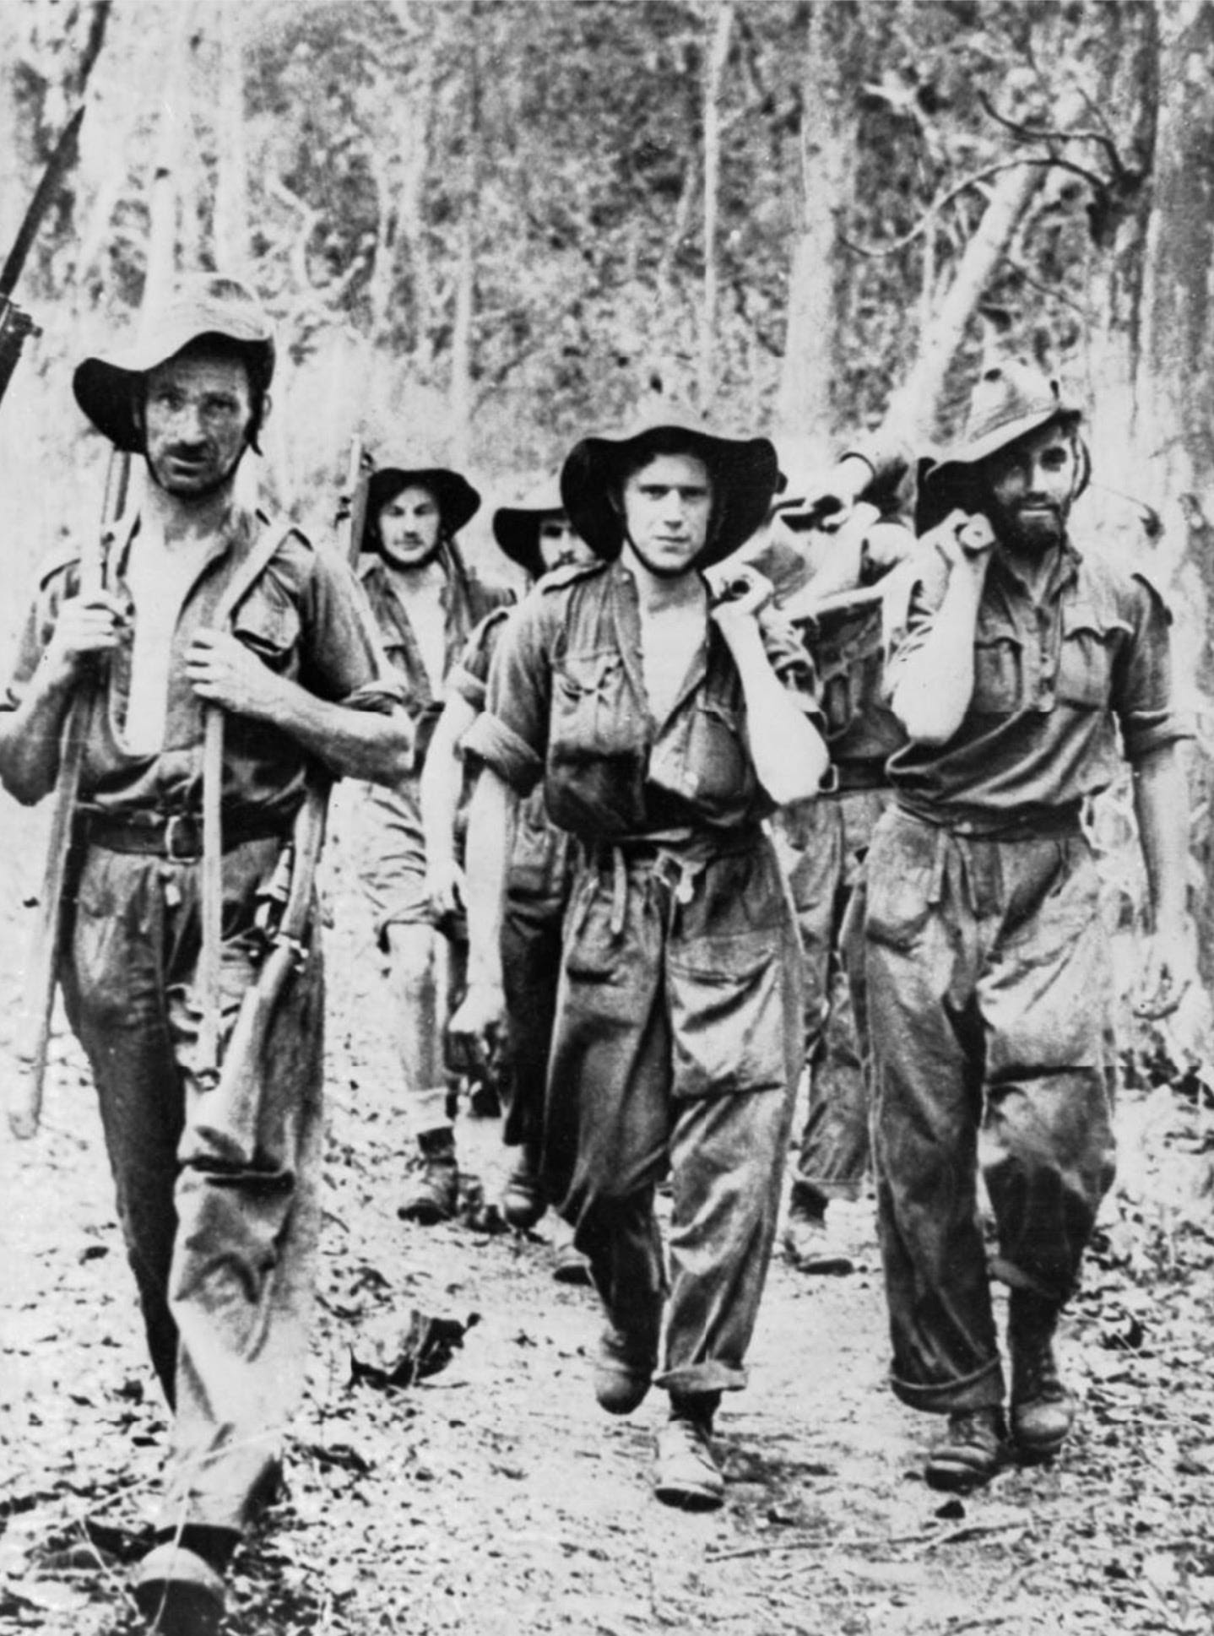
It was very difficult for the Chindits to extricate their wounded.
Despite all these difficulties, the Chindits succeeded in taking the fight to the enemy and smashed the myth that the Japanese were invincible in the jungle.
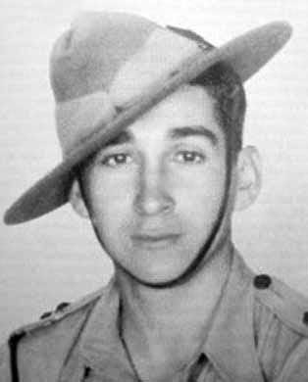
Second Lieutenant Harold James was the youngest officer and commanded Gurkha troops. He was awarded the Military Cross following the expedition.
Second Lieutenant Harold James
At Nankan Railway Station on 6th March 1943, Lt. James showed coolness and self confidence in his first action when leading his platoon into the attack.
On 23rd March 1943, during the crossing of the Irrawaddy, his platoon was sited in a position to prevent the enemy crossing a creek when the column was suddenly attacked by the enemy with small arms fire and mortars.
He immediately attacked them inflicting heavy casualties and preventing them from crossing, personally walking round his platoon while under fire and placing his men in the best positions.
This officer showed great devotion to duty throughout the campaign and great gallantry on many occasions.
Lt. James’ Subedar - an Indian officer ranking just below him - was awarded the Indian Distinguished Service Medal for the action on the 6th March. The recommendation² for his award tells us a little more about the nature of the fighting:
Subedar Kumba Sing Gurung
On 6th March 1943, at Nankan Railway Station, Subedar Kumba Sing Gurung was detached with one section and an anti-tank rifle to guard a track while demolitions were being carried out on the railway. Two lorry loads of Japanese infantry arrived and drove straight into the ambush which he had laid.
The majority were killed at the outset, but the remainder were reinforced. The Subedar continued to fight the enemy for two hours, gaining complete immunity from interruption for the parties engaged in demolishing the railway. He himself shot two of the enemy, on whom 15 casualties were inflicted without loss to our own troops.
During the whole of the campaign as Senior Gurkha Officer with his column he maintained the morale and discipline of his men under trying circumstances and upheld the finest tradition of the Gurkha Officer.
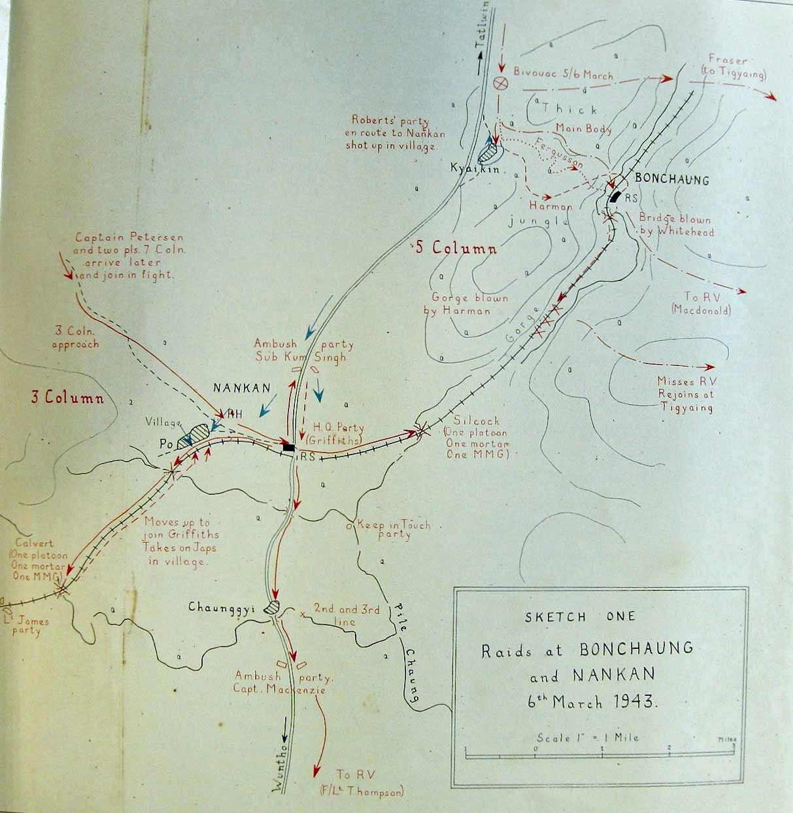
A subsequent sketch map summarising the Chindit action on the 6th March 1943.
1
Harold James: Across the Threshold of Battle
2
Chindit Longcloth 1943
For more on Operation Longcloth see the Chindit Society.

